Head of the Don

Doncaster, Sunday 6th October 2019

Competitor Instructions
The following is intended to make your visit to the Head of the Don easy and enjoyable and includes guidelines that are in place to help ensure the safety of you and others during the race. This Head Race is run under British Rowing Rules. All competitors must be aware of the “Row Safe” guide (see: http://www.britishrowing.org/taking-part/staying-safe/rowsafe) and must abide by its instructions.
Please ensure your crews read and understand the instructions below.

Key Personnel and Contact Numbers:
The nearest public telephone is located on Greenfield Lane, approximately 50 metres outside the Hexthorpe Park gates.
Chairman and Event Secretary, Adam Manson .……….….…………...…. 07979 893300
Race Safety Adviser, Adam Manson …………………………….….….…... 07979 893300
Entries Secretary & Registration, Carol McGlone ..….…….…..……......... 07752 270636
Race Committee Chairman, William McIlroy ……………..…...………….... 07836 327251
Regional Safety Advisor, Howard Holmes …...……………….………........ 07968 524149
Emergency ................................................................................................................. 999
Doncaster Fire Rescue Headquarters......................................................... 01302 344468
South Yorkshire Police ............................................................................... 0114 2202020
Doncaster Royal Infirmary ......................................................................... 01302 366666
Race Web Site: https://www.doncasterrowingclub.com/head-of-the-don.html

General
- The head race is based from Doncaster Rowing Club’s clubhouse in Hexthorpe Park, Greenfield Lane, Doncaster. Trailer parking is available in the Park, along with limited parking for cars. Other cars must park in the designated car parks or the streets around the Park. Please see the separate instructions and maps giving directions on how to reach the race location and where to park.
- The course covers 4,000 metres, starting by Doncaster Prison and finishing on the straight below Sprotbrough lock.
- Events are offered in the following categories, for open, women, mixed, juniors
Class | 8+ | 4x+ | 4x- | 4+ | 2x | 1x
Senior | X | X | X | X | X | X
Masters | X | X | X | X | X | X
Mixed | X | X | X | X | X
J18 / J16 | X |  | X | X | X | X
J15 / J14 |  | X |  |  | X | X
J13 |  | X |  |  | X

Class | Division 1 | Division 2
8+ | Open (Sen, Mas), WJ18, WJ16, Mixed | Women (Sen, Mas), J18, J16
4x+ | Women (Sen, Mas), J15, J14, J13 | Open (Sen, Mas), WJ15, WJ14, WJ13, Mixed
4x- | Open (Sen, Mas), WJ18, WJ16 | Women (Sen, Mas), J18, J16, Mixed
4+ | Women (Sen, Mas), J18, J16 | Open (Sen, Mas), WJ18, WJ16, Mixed
2x | Women (Sen, Mas), Mixed WJ15, WJ14, WJ13, J18, J16 | Open (Sen, Mas), J15, J14, J13, WJ18, WJ16
1x | Women (Sen, Mas), WJ15, WJ14, J18, J16 | Open (Sen, Mas), J15, J14, WJ18, WJ16

- Bands may be created where we receive a large number of entries.
- Crews that consider themselves to be “Beginners” should write this into the notes in BROE. If there are sufficient entries, we will create a Beginners’ band in that event.
- There are 2 Divisions as follows:
- Division 1: 10:30 am - All classes of boat specified in the poster.
- Division 2: 14:30 pm - All classes of boat specified in the poster.
- All Masters crews should enter as MasA or WMasA and the rowTIME handicapping system will automatically work out the finishing order. The Masters category will be determined by the age of the crew at close of entry.
- If necessary, the British Rowing Masters Handicap system will be used. For details see: Masters Handicap Events – Operating Notes 2010 at: http://www.britishrowing.org/upload/files/Association/Policies/HandicapOperatingNotes-2010.pdf
- Adaptive competitors should indicate in BROE2 in which Division they would like to row.
- Boats will generally be started in groups by boat type, with short gaps between different boat types.
- This year we will be using the rowTIME system and the results will be posted shortly after racing in each division has been completed. Prize giving will take place as soon as all crews have packed away their boats following Division 2. Crews that wish to leave before the prize-giving may collect prizes early.
- Entries will only be accepted via the BROE system. The closing date for entries is 3:00 pm on Saturday 28th September 2018.
- Entries should be made through the BROE online system. Payments can be made by cheque (made payable to “Doncaster Rowing Club”), electronic bank transfer (please see BROE for details), or on the day. All cheques sent by post must be received by Tuesday 1st October (to the address shown in BROE). Payments can also be made on race day.
- Enquiries should be directed to the Entries Secretary, Carol McGlone, at: carol.mcglone@hotmail.co.uk .
- Registration will be upstairs in the Doncaster Rowing Club clubhouse in Hexthorpe Park. Numbers, race day payments and any entry queries will be dealt with at the registration desk.
- Entry fees will be:
- Seniors/Masters: £9 per seat
- Juniors: £6 per seat.
- This is a demanding event and crews and their coxswains must be sufficiently competent to race. Anyone whom the race officials consider is not competent will not be allowed to race.
- You must carry a copy of these instructions with you in the boat.
- Make sure you have and are wearing adequate, warm clothing and hats and take these with you in the boat for the waits at the start and finish. As the river level can vary at this time of year and can cover the landing stages, we strongly recommend that all crew members bring Wellington boots. Competitors whom the marshals deem to be inadequately dressed will not be allowed to boat.
- Please follow the marshals’ instructions at all times.
- Coxswains must carry weights if they are required. If you are carrying weights please show the landing stage marshals before boating. The minimum racing weight for coxes are as follows: 55kg for Senior Open, Masters Open, J18, J16 and Mixed crews; 50kg for Senior Women, Masters Women, WJ18 and WJ16 crews; 45kg for all J15 and younger crews. To make up this weight a lighter coxswain shall carry dead-weights. Any dead-weights carried may be checked after any race in an event.
- Coxes will not be weighed before the race. However, the weight of coxes of winning crews may be checked after the race.
- All crews will be issued with two numbers: an “Empacher” number to be secured on the bow of each boat and a race number to be secured on the back of the bow person or sculler.
- All boats must have “Empacher” slots and crews will be issued with race numbers in Registration. Please ensure that your Empacher number is securely fixed to the bow of the boat, if necessary using tape to secure it (tape will be available in the Boat House compound). Empacher numbers will be collected as crews de-boat and any crews losing their number will be charged £2 for the replacement.
- Racing licence presentation may be requested prior to racing, crew substitution, or prize giving.
- All incidents (including potential and actual injury or damage to individual or equipment) must be reported, in the first instance, to a member of the Organizing Committee or a race marshal.
- There will be five launches for the purposes of safety on the course. In the event of technical problems with the launches, the Chairman of the Race Committee or Safety Officer can direct a suspension of racing. The co-ordinating umpire will be the person primarily responsible for summoning both medical and emergency cover, unless action may be taken with greater efficiency by any other official.
- If, during the course of the event, weather conditions present a safety hazard, the race committee may suspend racing either in full, or by event. If racing cannot be recommenced, winners of incomplete events shall be determined by the holder of the fastest race time.
- First Aid cover will be provided by the Red Cross, who will be located in the clubhouse and on one of the safety launches.
- Toilets are available in the Doncaster Rowing Club clubhouse and near the entrance of Hexthorpe Park. Showers are also available in the Park facilities.
- Prize giving will take place as soon as possible after the results of the second division are published. Any early winners may collect their prizes from Race Control before then.
- The risk of contracting Leptospirosis (Weil’s Disease) from recreational water is small. However, the serious nature of the disease is such that all competitors must be aware of the dangers and should take simple precautions to reduce the risk of infection:
- Cuts and abrasions (including blisters) should be covered with waterproof dressings.
- Wear footwear to avoid cuts and protect feet when paddling in the water or launching a boat.
- Shower after contact with the water.
- Wash hands thoroughly before eating and drinking.
If ‘flu-like symptoms develop shortly after contact with the water (1-3 weeks) then your doctor should be contacted and advised of the circumstances of exposure.

Instructions for Boating
- The intention is to get boats onto the water in a quick, safe and efficient manner, so that the races can start on time.
- All crews must be ready to proceed to the landing stages at least 20 minutes before the boating time stated on the Start Order Schedule. Crews will be called to the landings by marshals in reverse start order but should not wait to be called.
- You will not be allowed to warm-up upstream but ergos are available in the clubhouse if you wish to use them prior to boating.
- It is the responsibility of each member of the crew to ensure that their equipment is in a safe condition.
- Boats will be checked for safety by a marshal prior to boating, with particular attention being paid to the following: bow ball integrity, suitable buoyancy compartment hatches, shoe heel restraints, the Integrity of hull and fittings (e.g. damage-free boat and secure riggers).
- Boat safety checks will be done on the trestles provided at the top of the landing steps. Boats should be placed on the trestles right way up.
- To facilitate rapid boating, you must move all blades, kit, etc., close to the landing stage before carrying your boat to the landing stage.
- All boats must be launched facing downstream (to the right) and proceed immediately in that direction.
- As soon as your boat is afloat, you must get in and push off. Any adjustments to your boat should be made either before leaving the rigging area or after leaving the landing stage.
- When proceeding to the start, keep to the right of centre of the river. All overtaking crews must do so on the left and then pull back to the right.
- It is the responsibility of the crew which is overtaking to avoid a collision. Do not assume that other crews have seen you. Always shout if you are unsure of their position or if there is any danger of a collision.
- Clubs should ensure that their rowing members are trained in capsize drill. If you fall out of the boat do not swim away from it, as it will provide buoyancy. When safe to do so, swim to the nearest bank whilst holding on to the boat and await a safety launch.

Starting Instructions
- A start map will be on display in the boathouse and boats will be marshalled in ascending number order. Crews who arrive late at the start or who disobey marshals’ instructions may incur a time penalty.
- Crews should marshal facing towards the start in the direction of racing. Take care when turning, being considerate of other crews.
- Take careful notice of instructions issued by launch and bank marshals. The only time you may ignore these is if it would be unsafe to carry out the instruction you have received.
- Do not remove any warm clothing until you are warned that the race is about to start. You will be given approximately 2 minutes’ warning by 3 short blasts on an air horn before you are due to start moving up to the start.
- As you paddle up to the start you will be asked to stop about 50 metres from the start post and you should then wait until the starter tells you to go. Timing will commence at the start post.

During the Race
- The course is 4,000m long, starting by Doncaster Prison and finishing at the end of the straight near Sprotbrough Lock.
- The course has three major bends; a sharp right-hand bend just after the start, a left-hand bend starting at around 1,300m and a gradual right-hand bend starting from the boathouse and lasting until the railway bridge.
- Faster crews have right of way, so crews which are being overtaken must allow the overtaking crew to use the inside of any bend.
- This means on the first bend (just after the start) crews being overtaken should move to the left, then on the second major bend move to the right and on the finishing bend move to the left.
- We are one of the few head races where you race past the boathouse, which creates a great atmosphere. When you pass the boathouse you will be approximately half way over the course.
- Where possible, other river traffic will be stopped during the races. However, crews must remain vigilant at all times during the race and follow the navigation rules shown on the map that will be provided at registration.

Instructions for when you Finish the Race
- After passing the finish line, crews should continue paddling upstream until instructed to pull into either bank by a marshal. DO NOT TURN. Crews who disobey marshals’ instructions may incur a time penalty.
- No crews will be allowed back towards the landing stages until all crews have finished racing.
- As soon as you have stopped rowing put on warm clothing while you wait. As there is some current, it will be necessary to paddle occasionally to stop your boat drifting downstream and to maintain its position.
- Boats will only be instructed to start turning when all crews have finished racing. When instructed by a marshal, turn and proceed back downstream. Do not overtake any other crews unless instructed to do so by a marshal.
- As soon as a landing stage becomes available, you will be directed by the marshals where to go.
- Our intention is to move people off the water as rapidly and as safely possible, so please de-boat quickly.
- After putting your blades against the bank so they are not a trip hazard, lift your boat out of the water and take it to the car park before collecting your blades and kit.
- There are two exit gates to the boathouse compound. Bank marshals will tell you which gate to use when carrying your boat back to the park.
WE HOPE YOU HAVE AN ENJOYABLE DAY WITH US

Race Map
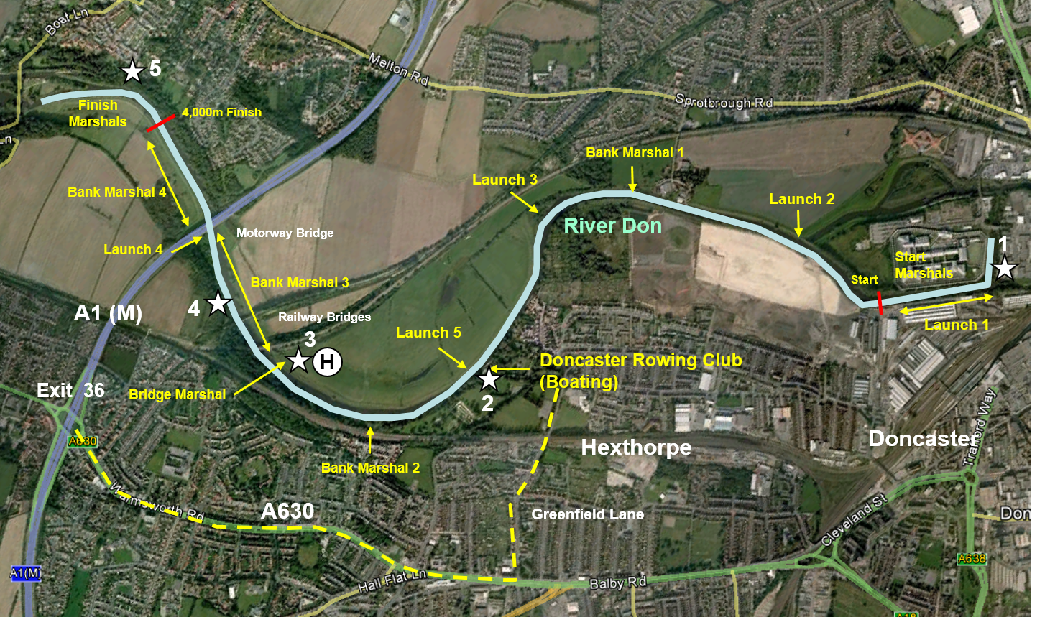

Egress Points

